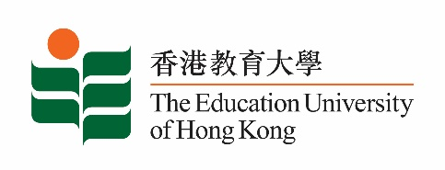
致： 传媒机构采访主任 (共 1页) 10 March 2023
To : News Editors (total: 1 page)

香港教育大学2023年 3月13日至 26日可供采访之活动一览
The Education University of Hong Kong (EdUHK) Events Calendar for 13 - 26 March 2023
本校诚邀 贵机构派员采访下列活动。传媒查询，请联络教大传讯处（电话：2948 6050）。
You are cordially invited to cover the events below. For media enquiries, please contact the Communications Office at 2948 6050.

以下活动或有人数限制，传媒请预先向主办部门登记。
There may be restrictions on the number of participants for the following event(s). Please contact the respective organiser(s) / department(s) for prior registration.

- 教大大埔校园 （新界大埔露屏路十号） / EdUHK Tai Po Campus (10 Lo Ping Road, Tai Po, New Territories)

日期  Date | 时间  Time | 活动  Event | 地点  Venue | 主办部门及公众查询  Organiser &  Public Enquiry | 备注  Remarks
2023-03-15 | 4 pm – 6:30 pm | 如何把同学们从元宇宙带回地球？拒绝上学  School refusal - Take our children back from the meta universe to our planet! | 教大大埔校园  D1-LP-03  D1-LP-03,  EdUHK Tai Po Campus | 主办部门 / Organiser:  特殊教育与辅导学系 Department of Special Education & Counselling  查询 / Enquiries:  Ms Yoyo Ng  电话 / Tel:  2948 8434 | 活动详情 / Details:  https://www.jcschooldiversity.hk/ls_talk_2023/

